While keeping these examples in mind, the following questions can help identify which individuals exercise substantial control over your company. Multiple criteria can apply to one individual.
Substantial control question: | Answer | If response is “Yes”:
1. Does your company have a president, chief financial officer, general counsel, chief executive officer, or chief operating officer? | - Yes  - No | There are senior officers  in your company.
2. Does your company have any other officers that perform functions similar to those of  a President, chief financial officer, general counsel, chief executive officer, or chief operating officer?  Note: One individual may perform one or more functions for a company, or a company may not have an individual who performs any of these functions. | - Yes  - No
3. Does your company have a board of directors or similar body AND does any individual have the ability to appoint or remove a majority of that board or body? | - Yes  - No | There are individuals with appointment or removal authority over your company.
4. Does any individual have the ability to appoint or remove a senior officer of  your company? | - Yes  - No
5. Does any individual direct, determine, or have substantial influence over important decisions made by your company, including decisions regarding your company’s business, finances, or structure?  Note: Certain employees who might fit this description are nevertheless exempt from the beneficial owner definition. See section 2.4 for more information. | - Yes  - No | There are important decision-makers over your company.
6. Are there any other individuals who have substantial control over your company in ways other than those identified in 1-5 above? | - Yes  - No | There are individuals to whom the catch-all would apply.

Complete Step 1: Once you have reviewed the examples and questions for exercising substantial control above, you will have enough information to complete Step 1 (identify the individuals who meet the substantial control criteria for your company). The individuals you have identified will be reported as beneficial owners in your company’s BOI report unless they qualify for an exception, as discussed in the next section of the chapter (section 2.4).
Step 2: Individuals may directly or indirectly own or control ownership interests. Individuals can own or control ownership interests through contracts, arrangements, understandings, relationships, or otherwise.
Examples of direct ways to own or control ownership interests in a reporting company are:

Note for trusts: The following individuals may hold ownership interests in a reporting company through a trust or similar arrangement:
- A trustee or other individual with the authority to dispose of trust assets.
- A beneficiary who is the sole permissible recipient of trust income and principal or who has the right to demand a distribution of or withdraw substantially all of the trust assets.
- A grantor or settlor who has the right to revoke or otherwise withdraw trust assets.
      - Joint ownership with one or more other persons of an undivided interest in an ownership interest.
Examples of indirect ways to own or control ownership interests in a reporting company are:
      - Owning or controlling one or more intermediary entities, or the ownership interests of any intermediary entities, that separately or collectively own or control ownership interests of a reporting company.
      - Through another individual acting as a nominee, intermediary, custodian or agent.
While keeping these examples in mind, the following questions can help identify what types of ownership interests are relevant for your company. A company may have more than one type of ownership interest.

Ownership interest question: | Answer | If response is “Yes”:
1. Does your company issue equity, stock, or any | - Yes | Your company has ownership interests that are equity, stock, or voting rights.
similar instruments that confer voting power? | - No
2. Does your company issue any pre- | - Yes
organization certificates or subscriptions? | - No
3. Does your company issue any transferable shares
of, or voting trust certificates or certificates of
deposit for:  - an equity security,  - interest in a joint venture, or  - certificate of interest in a business trust? | - Yes  - No
4. Do individuals hold capital or profit interests in your company (sometimes referred to  as “units”)? | - Yes  - No | Your company has ownership interests that are capital or profit interests.
5. Does your company issue any instruments convertible into any share, equity, stock, voting rights, or capital or profit interest?  Note: It does not matter whether anything must be paid to exercise the conversion. | - Yes  - No
 |  | Your company has ownership interests that are convertible instruments.
6. Does your company issue any future on any convertible instrument? | - Yes  - No
7. Does your company issue any warrant or right to purchase, sell, or subscribe to a share or interest in equity, stock, or voting rights, or capital or profit interests? | - Yes  - No
Note: It does not matter if such warrant or right is a debt.
8. Does your company issue any non-binding put, call, straddle, or other option or privilege of buying or selling equity, stock, or voting rights, capital or profit interest, or convertible instruments?  Note: Options or privileges created by others without the knowledge or involvement of your company do not apply. | - Yes  - No | Your company has ownership interests that are options or privileges.
9. Does your company have any other instrument, contract, arrangement, understanding, relationship, or mechanism to establish ownership? | - Yes  - No | The catch-all ownership interest applies to your company.

Complete Step 2: Once you have reviewed the examples and questions for ownership interests above, you will have enough information to complete Step 2 (identify the individuals who hold ownership interests in your company). Step 3 will help you identify which of these individuals own or control 25 percent or greater of the ownership interests in your company. The individuals who own or control 25 percent or more of the ownership interests in your company will be reported as beneficial owners in your company’s BOI report unless they qualify for an exception, as discussed in the next section of the chapter (section 2.4).
Step 3: After identifying what types of ownership interests apply to your company and who owns or controls them, you must determine who owns or controls 25 percent or more of those ownership interests.
If your company has issued any options, privileges, or convertible instruments:
„ Assume they have been exercised or converted in all calculations below.
If your company issues shares of stock, is a corporation (including a Subchapter S corporation), or is not a corporation but is treated as one for federal income tax purposes:
„ Calculate each individual’s ownership interest as a percentage of the total shares of stock issued. If some shares of stock that your company issues have more voting power or represent more of the value of the company than other shares (for instance, if your company issues both series A shares with one vote per share and series B shares with ten votes per share), you will need to make the following two calculations. The individual’s ownership interest will be the larger of the two percentages:

Total combined voting power of all classes of the individual’s ownership interests  ÷  Total outstanding voting power of all classes of ownership interests entitled to vote  =  Individual’s voting power % | Total combined value of the individual’s ownership interests  ÷  Total outstanding value of all classes of ownership interests  =  Individual’s ownership interest value %
If your company, including if your company is treated as a partnership for federal income tax purposes, issues capital or profit interests:
„ Apply the following calculation:
Individual’s capital and profit interests
÷
Total outstanding capital and profit interests
=
Individual’s capital and profit interests %

If none of these calculations apply to your company:
„ Identify any individual who owns or controls 25 percent or more of any class or type of ownership interest of the company.

Complete Step 3: After you have applied these scenarios to your company’s ownership interests, you will have enough information to identify the individuals who own or control 25 percent or greater of the ownership interests in your company. You must report the individuals who own or control 25 percent or more of the ownership interests in your company as beneficial owners in your company’s BOI report unless they qualify for an exception, as discussed in the next section of the chapter (section 2.4).
Examples of how to determine beneficial owners:
The following examples show how to determine beneficial owners across a variety of types of company structures. These examples assume that no exceptions apply to the beneficial owners, as discussed in the next section of the chapter (section 2.4). In the infographics for the examples, beneficial owners are noted by circles and non-beneficial owners are noted by triangles.
Example 1: The reporting company is a limited liability company (LLC). Individual A is the sole owner and president of the company and makes important decisions for the company. No one else owns or controls ownership interests in the company or exercises substantial control over the company.
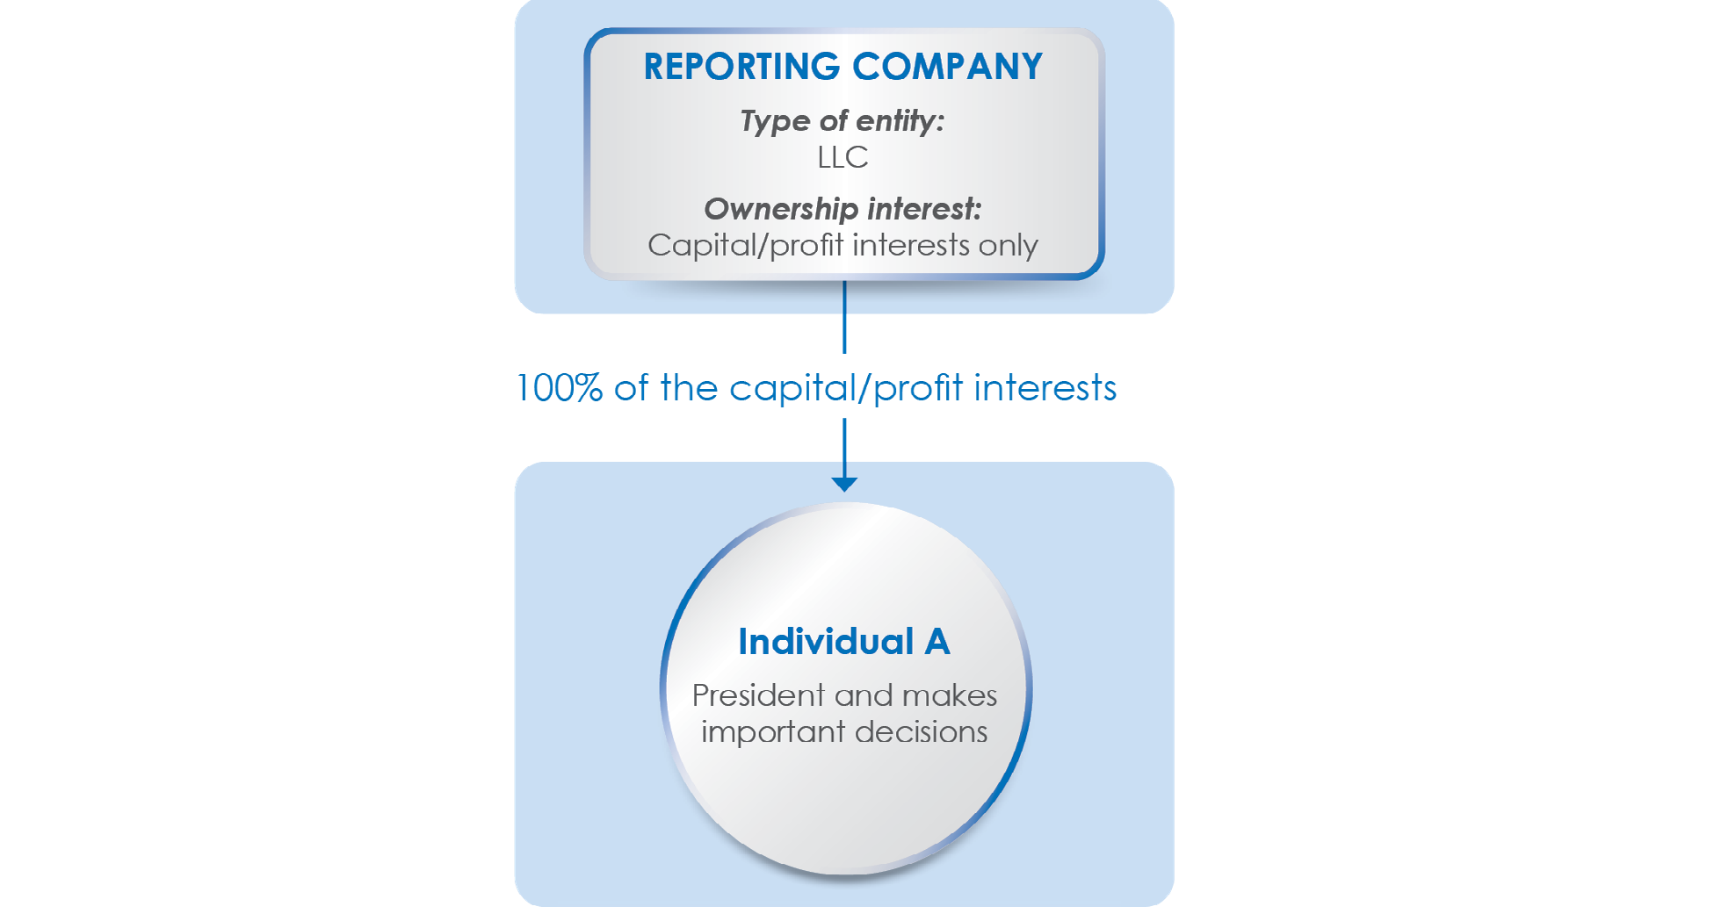

Individual A is a beneficial owner of the reporting company in two different ways, assuming no other facts. First, Individual A exercises substantial control over the company because Individual A is a senior officer of the company (the president). Second, Individual A is also a beneficial owner because Individual A owns 25 percent or more of the reporting company’s ownership interests.
Because no one else owns or controls ownership interests in the LLC or exercises substantial control over it, and assuming there are no other relevant facts, Individual A is the only beneficial owner of this reporting company, and Individual A’s information must be reported to FinCEN.

Example 2: The reporting company is a corporation. The company’s total outstanding ownership interests are shares of stock. Three people (Individuals A, B, and C) own 50 percent, 40 percent, and 10 percent of the stock, respectively, and one other person (Individual D) acts as the president, for the company, but does not own any stock.
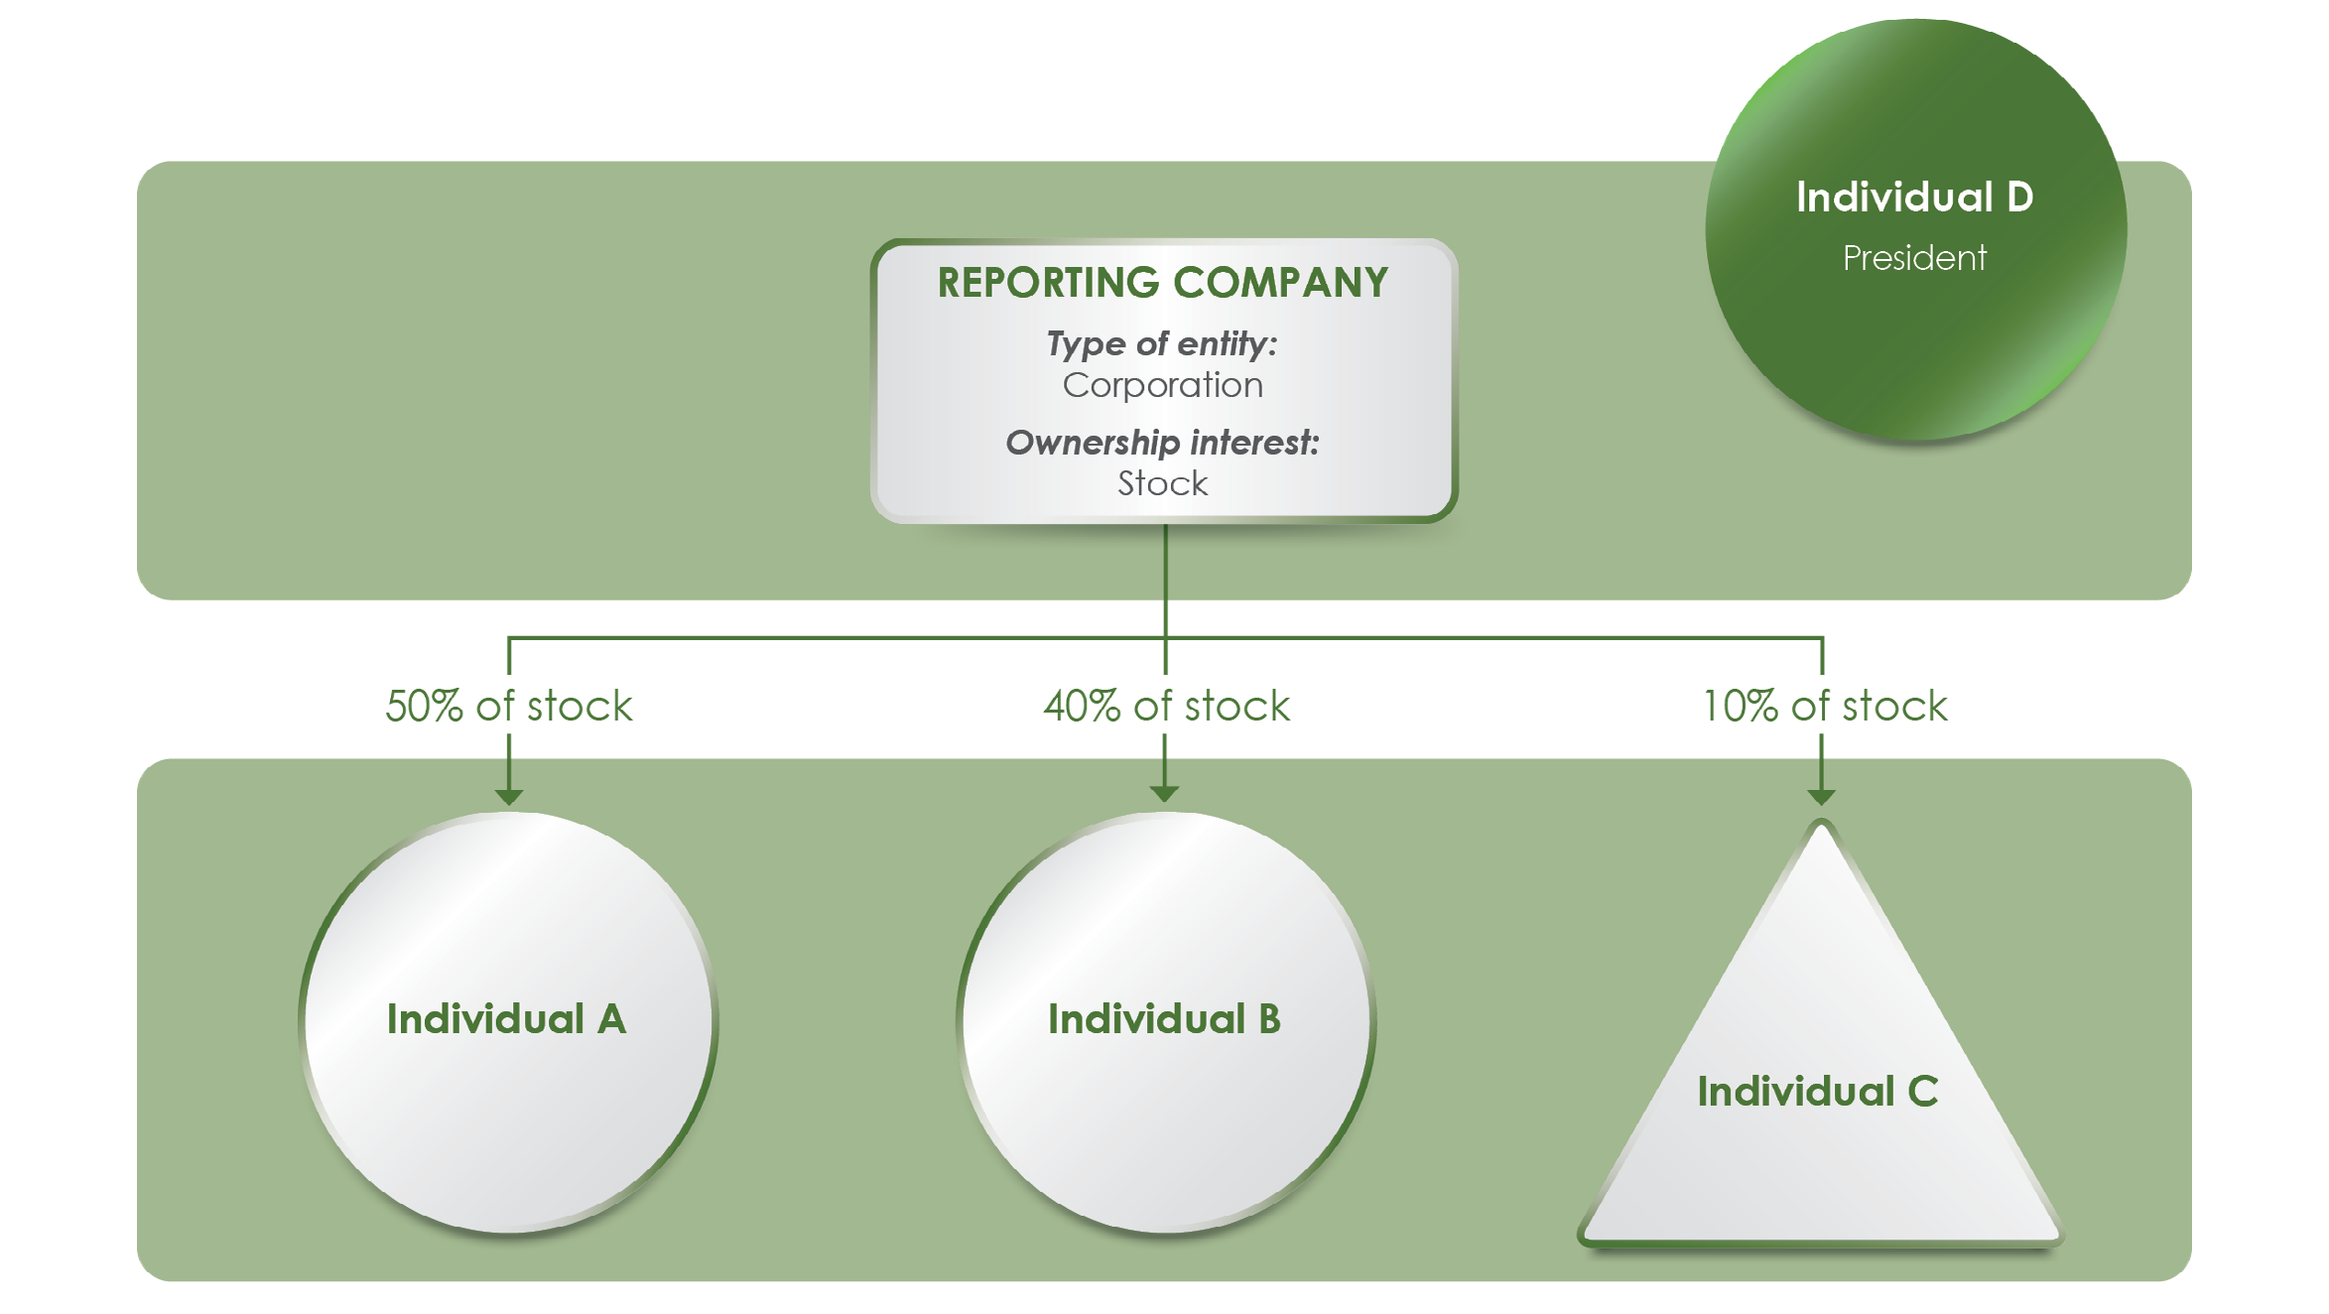

Assuming there are no other relevant facts, Individuals A, B, and D are all beneficial owners of the company and their information must be reported. Individual C is not a beneficial owner.
Individual A owns 50 percent of the company’s stock and therefore is a beneficial owner because 50 percent is greater than the threshold of 25 percent or more of the company’s ownership interests.
Individual B owns 40 percent of the company’s stock and therefore is a beneficial owner 40 percent is also greater than the threshold of 25 percent or more of the company’s ownership interests.
Individual C is not a senior officer of the company and does not directly or indirectly exercise any substantial control over the company.
Individual C also owns 10 percent of the company’s stock, which is less than the 25 percent or greater interest needed to qualify as a beneficial owner by virtue of ownership interests. Individual C is therefore not a beneficial owner of the company.
Individual D is president of the company. As a senior officer of the company, Individual D exercises substantial control over the company and is therefore a beneficial owner, regardless of whether or not Individual D owns or controls 25 percent or more of the company’s ownership interests.

Example 3: The reporting company is an LLC with two managers, Individuals A and C. Individual A also owns 50 percent of the “membership units” in the LLC while Individual C does not. Individual B owns the remaining membership units in the LLC but is not a manager.
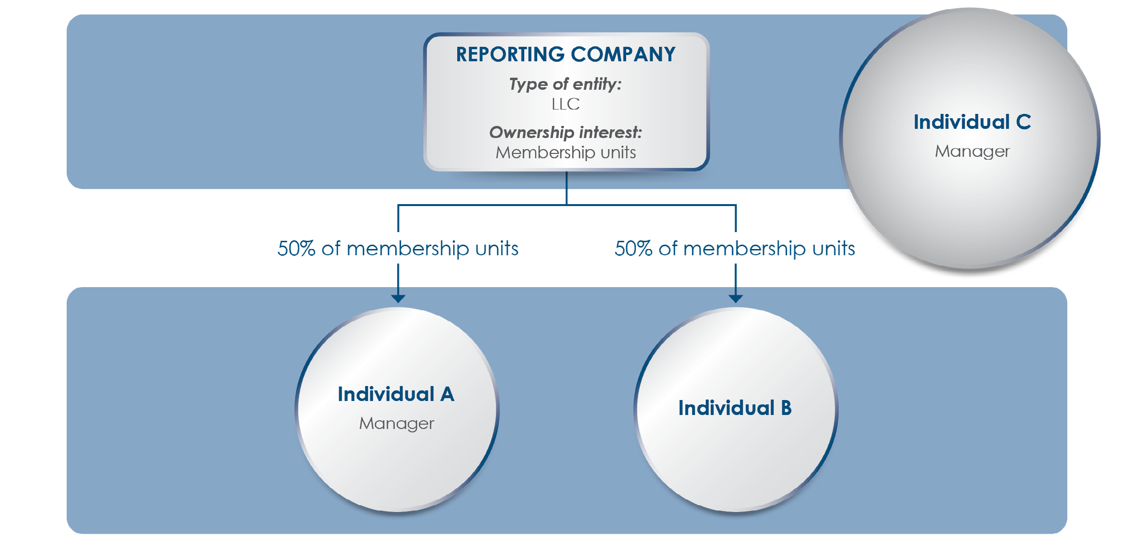

Owners of membership units (which are a type of “capital or profit interest” ownership interest) in an LLC are sometimes called “members” of the LLC. A member may not automatically be required, or authorized, to make decisions for the LLC; depending on the internal organization of the LLC, however, a member may also be a “manager.” In this example, Individual A is a member and a manager. Individual B is a member but not a manager, while Individual C is a manager but not a member. All three are beneficial owners of the reporting company.
Individual A is a manager of the LLC and owns 50 percent of the company’s membership units. Individual A exercises substantial control over the LLC because Individual A makes important decisions for the LLC in the role of manager. Individual A also owns 50 percent (which is greater than the 25 percent or more threshold) of the company’s ownership interests. Individual A is therefore a beneficial owner of the reporting company in two different ways, by exercising substantial control and owning or controlling 25 percent or more of the ownership interests.
Individual B owns 50 percent (which is greater than the 25 percent or more threshold) of the LLC’s membership units. That makes Individual B a beneficial owner of the LLC even though Individual B is not a manager and does not make important decisions or otherwise exercise substantial control over the LLC.
Individual C is a manager of the LLC and makes important decisions on its behalf, thereby exercising substantial control over it. Individual C does not own any of the LLC’s membership units (the ownership interests) but is nevertheless still a beneficial owner because the individual exercises substantial control.

Example 4: A reporting company is a corporation with multiple indirect owners through Company Y and Company Z.
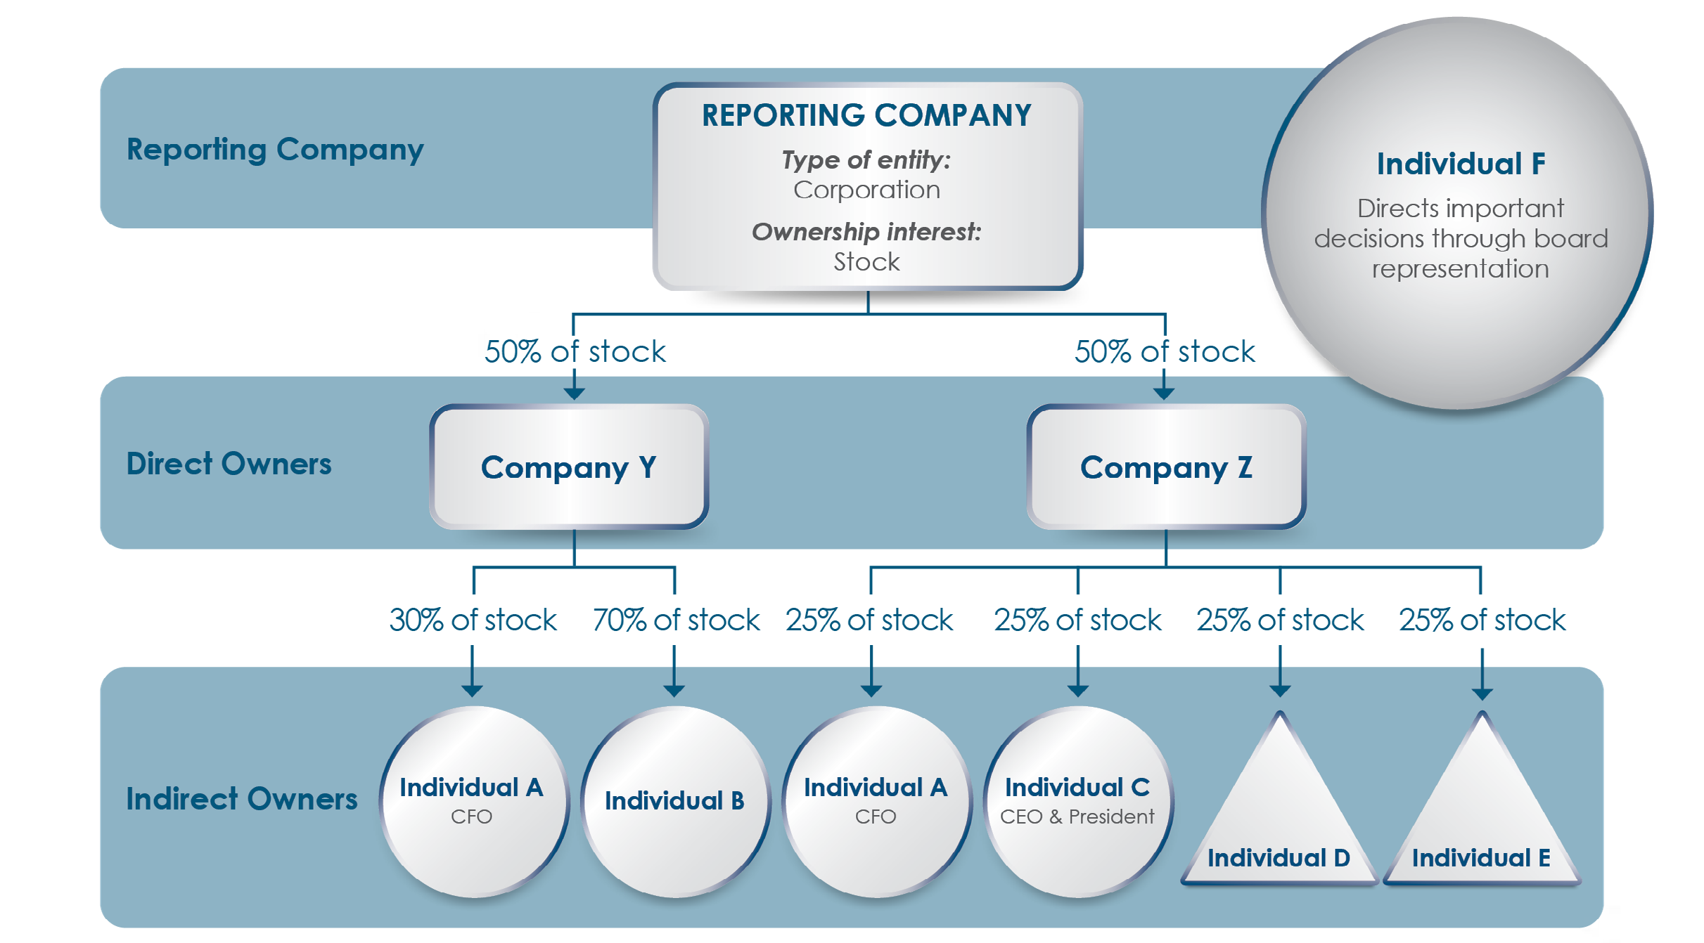

In this example, Individuals A, B, C, and F are beneficial owners.

Individual A is the reporting company’s Chief Financial Officer and is therefore a senior officer, which under the Reporting Rule means that Individual A exercises substantial control over the company. Individual A also indirectly owns 27.5 percent of the reporting company’s stock through direct ownership of Company Y and Company Z, which each own 50 percent of the reporting company’s stock. (Individual A owns 30 percent of Company Y’s stock and 25 percent of Company Z’s stock. Therefore, Individual A owns 15 percent of the reporting company’s stock through Company Y (50% × 30% = 15%) and 12.5 percent of the reporting company’s stock through Company Z (50% × 25% = 12.5%). Adding these two percentages together equals
27.5 percent of the reporting company’s stock.) Individual A is therefore a beneficial owner in two different ways, by exercising substantial control and owning or controlling 25 or more of the ownership interests of the reporting company.
Individual B indirectly owns 35 percent of the reporting company’s stock through Company Y, which owns 50 percent of the reporting company’s stock. (Individual B owns 70 percent of Company Y’s stock (50% × 70% = 35%)). Individual B does not exercise substantial control.
Individual B is a beneficial owner by owning or controlling 25 percent or more of the reporting company’s ownership interests.

Individual C is the reporting company’s Chief Executive Officer and president and is therefore a senior officer who exercises substantial control. Individual C indirectly owns 12.5 percent of the reporting company’s stock. To calculate Individual C’s indirect ownership interests in the reporting company, multiply the ownership interest of Individual C in Company Z by the ownership interest of Company Z in the reporting company. Individual C owns 25 percent
of Company Z’s stock and Company Z owns 50 percent of the reporting company’s stock.
Therefore, Individual’s C ownership interests in the reporting company are 12.5 percent (25%
× 50% = 12.5%), which is less than the 25 percent ownership interest threshold. Accordingly, Individual C’s ownership interests in the reporting company do not make Individual C a beneficial owner, but Individual C is nevertheless a beneficial owner because Individual C exercises substantial control over the reporting company.

Similar to Individual C, Individuals D and E own 25 percent of Company Z’s stock, and each therefore indirectly owns 12.5 percent of the reporting company’s stock. In contrast to

Individual C, Individuals D and E do not exercise substantial control over the reporting company.

Individuals D and E are not beneficial owners.

Individual F is on the company’s board of directors and makes important decisions on the reporting company’s behalf, thereby exercising substantial control over it. Individual F does not own or control any stock in the reporting company. Individual F is therefore a beneficial owner by exercising substantial control over the reporting company, but not through holding ownership interests in it.

